Installing Visual Studio Code and Connecting it with Anaconda

- Visual Studio Code also known as VS code is a code editor developed my Microsoft.

- In the Stack Overflow 2023 Developer Survey VS code was the most popular environment tool

- I will use VS code for this class. If you have a different favorite code editor, you are welcome to use it, but all the lecture notes and examples will be presented in VS code.

Installation process
- Go to the Visual Studio Code Website and select your operating system (Windows, Mac, etc.).
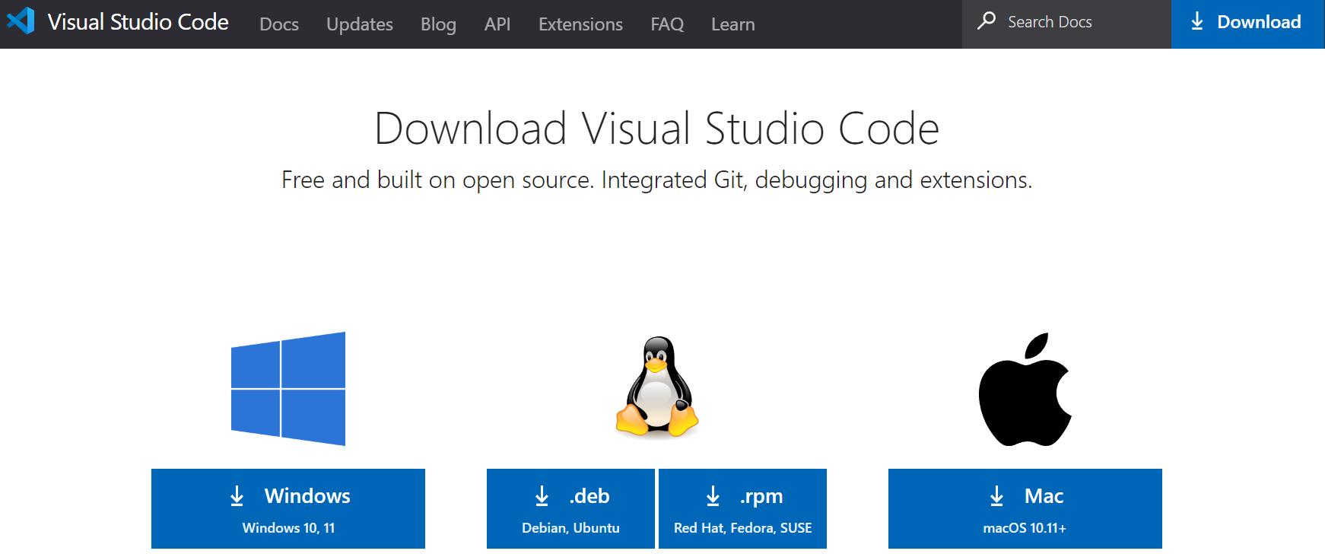

- Run the VS code executable. I recommend you use the default options in the installation process.
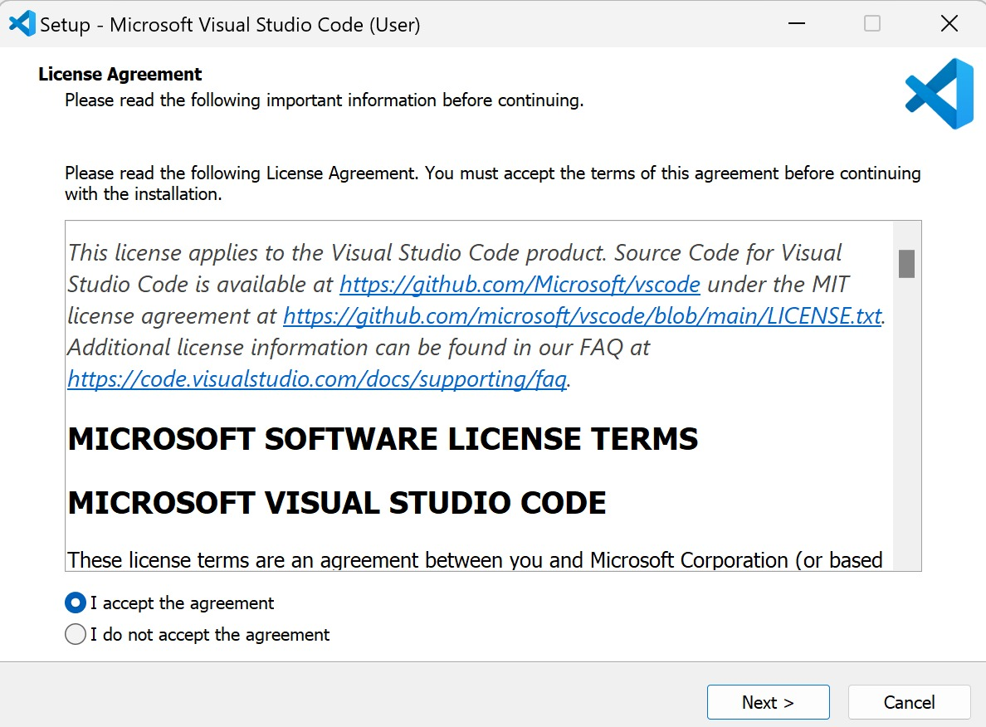
- Once the installation is complete, you will see a VS code window similar to this:
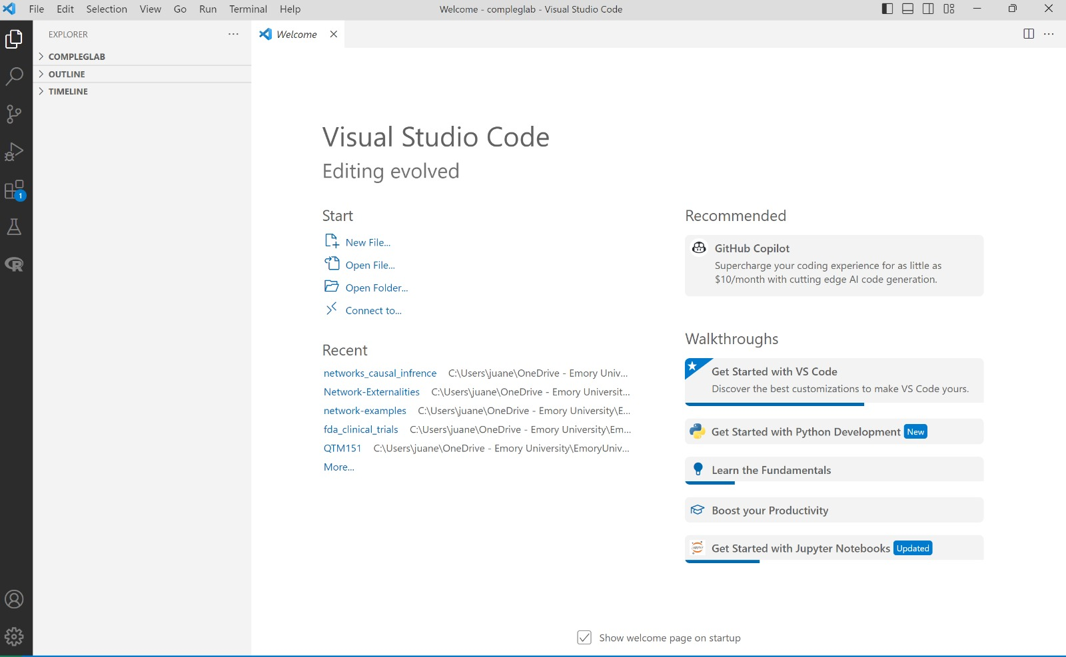

Note: the explorer folders on the left and the welcome message may be different for you, but that’s not a problem.

Connecting VS code and Anaconda

- Install the Python extension in VS Code
https://marketplace.visualstudio.com/items?itemName=ms-python.python
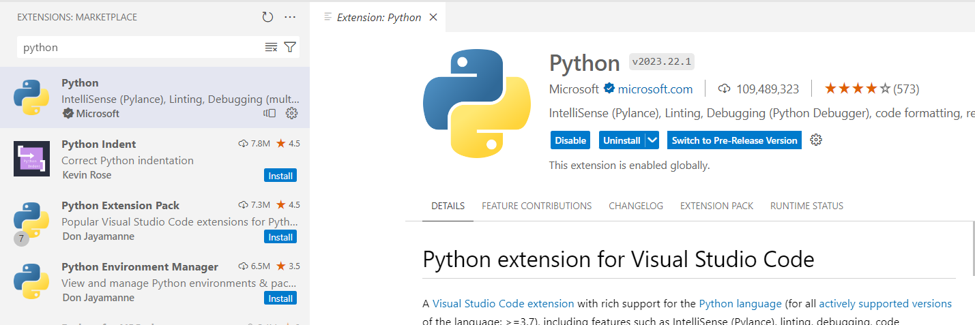

- Install the Jupyter extension in VS Code
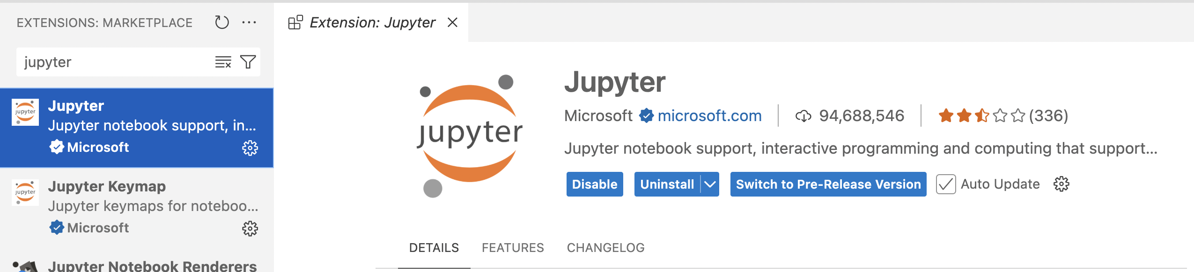

- To connect Anaconda with VS code, we will change the Python Interpreter. To do so, type CTRL + SHIFT + P to open the settings palette:
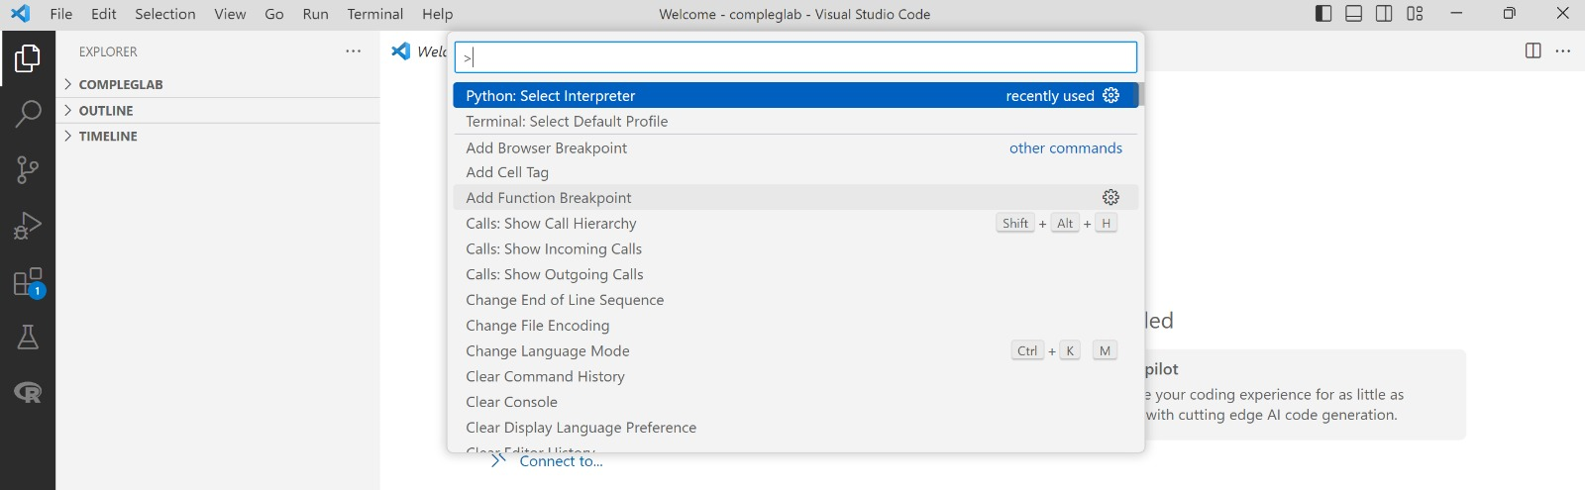

- Select the “Python: Select Interpreter” option. If VS code recognizes anaconda (which is usually the case), you will see the “Python 3.11.4 (‘base’)” option (or a more recent version depending on your computer). The ‘base’ in parentheses refers to what is known as an Anaconda virtual environment. We will discuss the idea of virtual environments more in class.
Note: the python version (in this example 3.11.4) can change depending on the Python version you installed using Anaconda, but that should not be an issue.
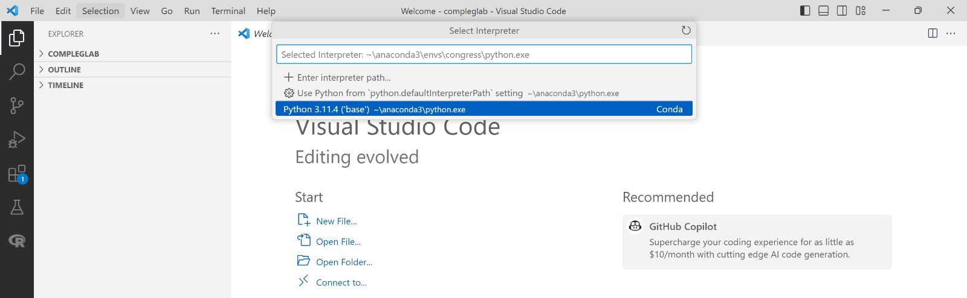

- We will check that the connection is working during our first class.

